Section A – Multiple Choice Questions (5 marks)

Question 1
The following table indicates the quarterly Consumer Price Index(CPI) outcomes for a hypothetical economy.
 | CPI
June 2020 | 100
September 2020 | 102
December 2020 | 103
March 2021 | 107
June 2021 | 109

With reference to the data in the table, the annual rate of inflation for the year ended June 2021 is
- 2%
- 4%
- 5%
- 9%

Question 2
The war in Ukraine over the early part of 2022 resulted in Australian petrol prices soaring above $2 per litre. This tends to:

A. increase cost inflation and cause the underlying rate of inflation to climb above the headline rate of inflation
B. increase cost inflation and cause the headline rate of inflation to climb above the underlying rate of inflation
C. increase demand inflation and cause the underlying rate of inflation to climb above the headline rate of inflation
D. increase demand inflation and cause the headline rate of inflation to climb above the underlying rate of inflation

Question 3
The Australian economy is currently in the recovery phase of the business cycle. This means that:
A. Economic growth and inflation will be rising while unemployment and incomes are falling
B. Economic growth and inflation will be falling while unemployment and incomes will be rising
C. Economic growth, inflation and income will be rising, while unemployment will be falling
D. Economic growth, inflation, interest rates and unemployment will be rising.

Question 4
Each of the following events is likely to increase living standards, with the exception of:

A. A rise in real GDP per capita
B. A rise in literacy rates
C. A fall in crime rates
D. A rise in mental illness

Question 5
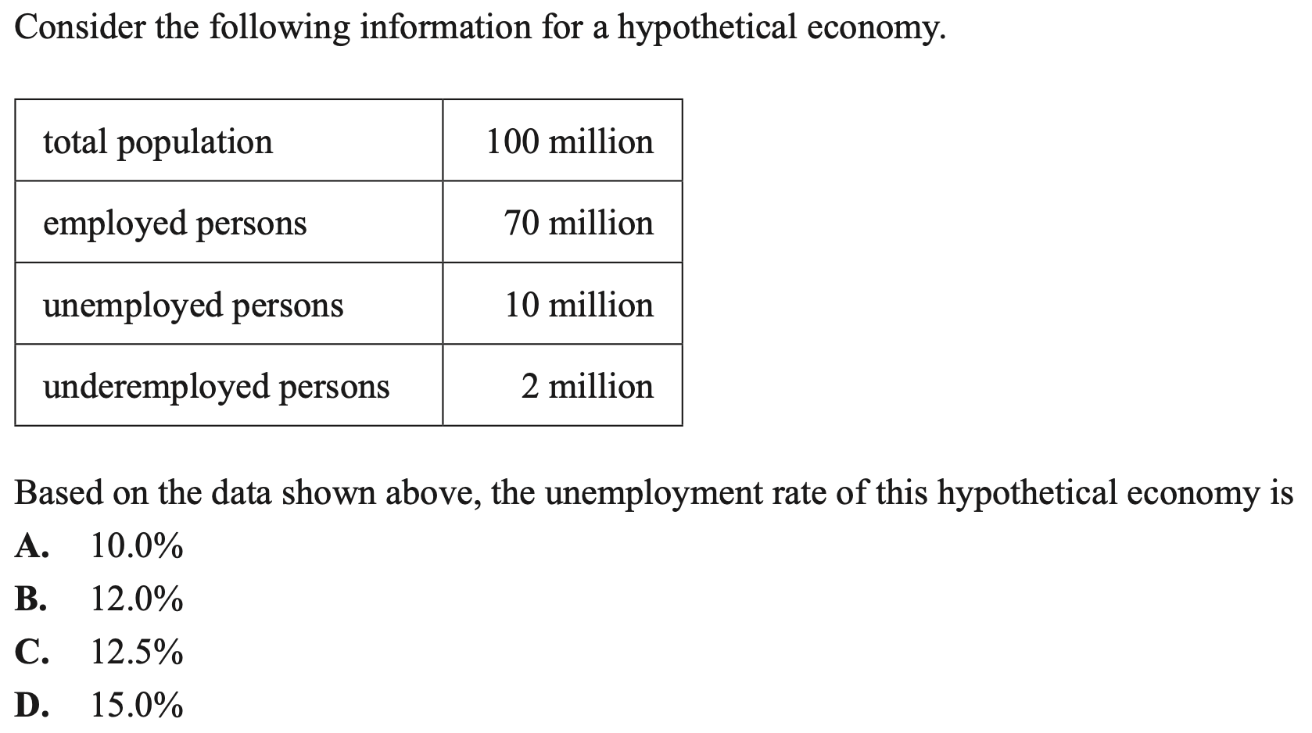
Section B - Short Answer Questions (35 marks)

Question 1 (13 marks)

a. Distinguish between hidden and disguised unemployment (disguised = underemployment)
3 marks
Hidden unemployment is when potential workers have been discouraged from looking for employment and have therefore left the labour force, whereas disguised unemployment is when a worker is employed but are willing and able to work more hours than they are currently. The key difference between the two is that hidden unemployed are not counted as being part of the labour force, while underemployed are considered employed and therefore are part of the labour force.

b. Outline two types of unemployment that occur in the Australian economy.
2 marks
One type of unemployment is cyclical unemployment, which is unemployment that occurs when there is a deficiency of aggregate demand (downturn in business cycle) which decreases the derived demand for labour in the economy. A second type of unemployment in the economy is structural unemployment, which is a ‘natural’ type of unemployment. Structural unemployment is when there is a mismatch between the skills available in the economy and the skills in demand from firms.

c. Identify and explain one factor that has had a positive influence on aggregate demand and the goal of full employment over the last two years.
4 marks
Note: this answer is somewhat out of date because interest rates have increased over the last 12 months)
One factor that has had a positive influence on aggregate demand (AD) and the goal of full employment is a record low cash rate. In 2020 the Reserve Bank of Australia (RBA) decreased the cash rate from 0.75% to 0.1%, and it has remained at 0.1% for the entirety of 2021. This decreased interest rates in the economy, which lowered the costs of borrowing for households, decreasing their propensity to save and increasing the incentive to spend, which increased private consumption expenditure (C) in the economy. Furthermore, this also would increase private investment spending in the economy (I), increasing AD. An increase in AD increased the derived demand for labour resources in the Australian economy, decreasing cyclical unemployment and therefore having a positive impact on the goal of full employment, which is to have the an absence of cyclical unemployment in the economy, and have the lowest unemployment rate possible without triggering inflation (the NAIRU), which is a target of approximately 4-4.5%.
(Note: unemployment was 4% at the time)

Unemployment rate in Australia over the last 12 months

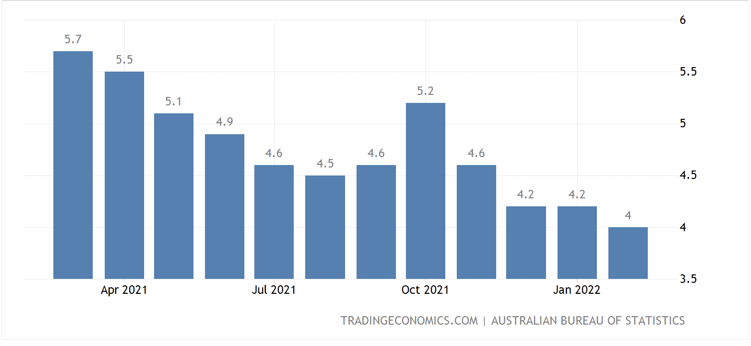

d. Describe the trend in the unemployment rate over the last 12 months and describe the impact this trend would have on material and non-material living standards in Australia.
4 marks
1 mark for describing the overall trend as downward

1 mark for use of data (5.7% to 4%)

1 mark to link to material living standards and how increase in employment would increase real income levels and access to goods and services

1 mark for link to non-material living standards and how increase in employment increases general wellbeing as it gives people purpose, relieves financial stress and creates social connections (or anything else that is appropriate)
Question 2 (8 marks)
a. Outline what is meant by the goal of strong and sustainable economic growth and explain two reasons why this goal is pursued by the government.
4 marks
Note: this was technically taken out of the study design in 2023 (and replaced by consequences of not achieving it) but still worth students knowing.

The government’s goal for strong and sustainable economic growth is to achieve the highest growth rate possible, consistent with strong employment growth, but without running into unacceptable inflationary, external or environmental pressures. This is a target of 3-3.5% real GDP per annum.
One reason the government pursues this goal is strong economic growth leads to higher employment levels. More national production will increase the demand for labour resources, increasing employment opportunities in Australia and decreasing the unemployment rate. Another reason why the government pursues the goal of strong and sustainable economic growth is a greater ability of government to provide essential services. Higher level of national income leads to higher levels of taxation revenue for the Government, which then give them a greater ability to provide essential services like healthcare and education which service to increase the non-material living standards of the Australian population.

b. Identify and explain one aggregate supply factor that would have had a positive impact on the goal of strong and sustainable economic growth in Australia over the last two years.
4 marks

One aggregate supply factor that would have had a positive influence on the goal of strong and sustainable economic growth is an increase in the quantity of labour resources in the Australian economy, through an increase in the labour force participation rate. The labour force participation rate is the percentage total of the ‘working age’ population that is willing and able to work, and this rate increased from approximately 63% in 2020 to approximately 66% currently. This increases the quantity of labour resources available in the economy, increasing the ability of firms to produce goods and services, increasing productive capacity and aggregate supply (AS). Moreover, a greater supply of labour in the labour market will mean firms have greater bargaining power and put downward pressure on wages over time. This will lower costs of production for firms, further increasing AS and allowing for an increase in non-inflationary economic growth over time. This is a positive for the goal of strong and sustainable economic growth, which is to achieve the highest growth rate possible, consistent with strong employment growth, but without running into unacceptable inflationary, external or environmental pressures, around 3-3.5% real GDP per year.
Question 3 (14 marks)

Australian dollar ($AUD) against the US dollar ($USD)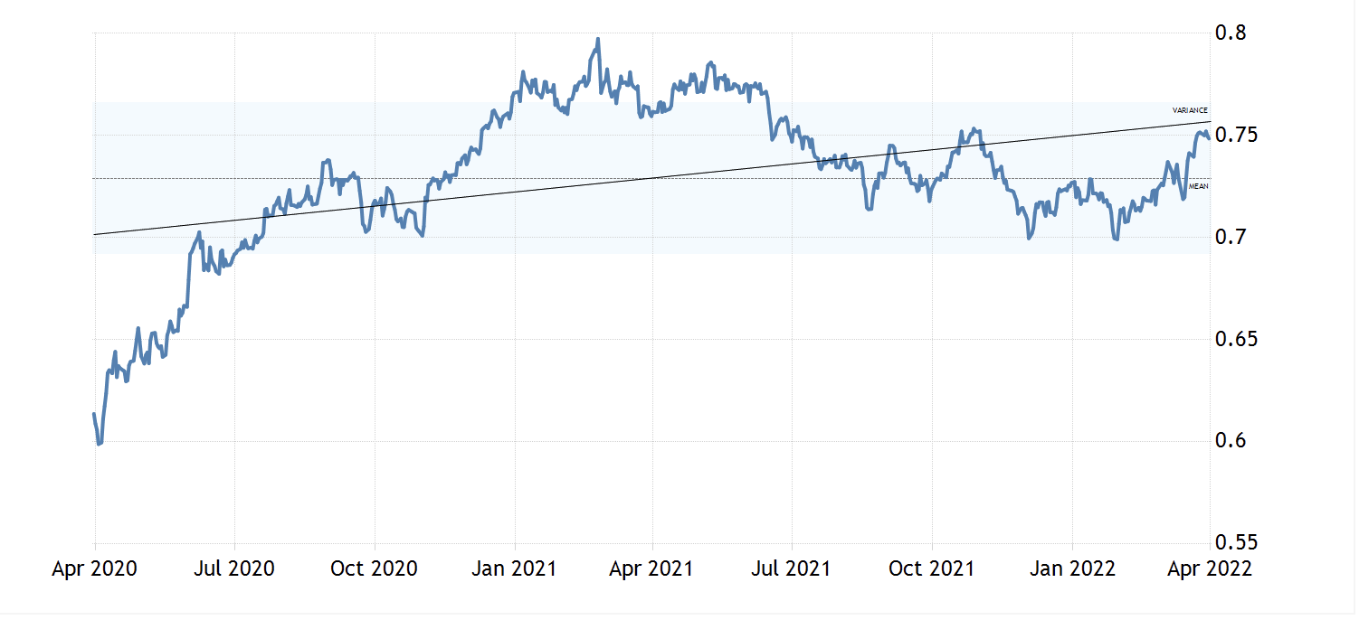
a. Referring to the graph above, analyse how the trend in the exchange rate over the last 2 years would influence the inflation rate in Australia, ceteris paribus.
5 marks
1 mark for referencing data in graph.
2 marks for accurate explanation of how the appreciation would decrease demand inflation (one mark for limited explanation)
2 marks for accurate explanation of how the appreciation would decrease cost inflation (one mark for limited explanation)

Australian inflation rate April 2020- April 2022
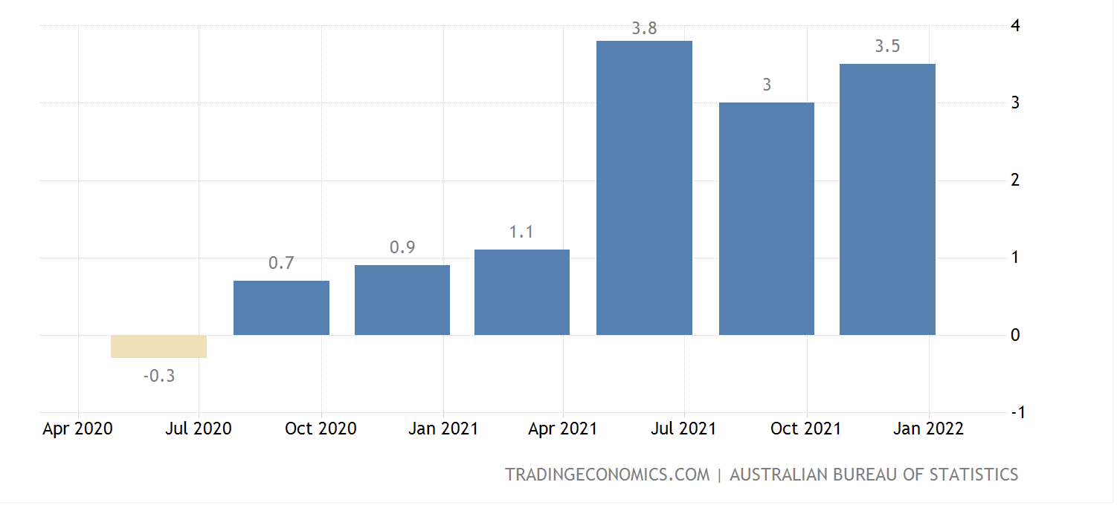
b. Referring to the data above, assess the extent to which the Australian economy has achieved the goal of low inflation over the last two years.
3 marks
The goal of low inflation is for consumer price inflation to be 2-3%, on average, over time. The Australian economy has been able to achieve the goal of low inflation to a small extent over the last two years. The economy was well below the goal of 2-3% for all of 2020 and some of 2021, with the inflation rate ranging from -0.3% to 1.1%. The second half of 2021 and start of 2022 saw the inflation rate mostly above the goal, as high as 3.8%, while sitting exactly at the goal of 3% in one quarter. Overall, the average inflation rate over this period was 1.8%, which is below the goal of low inflation and therefore the government has not achieved its goal.

c. Identify and explain one aggregate supply factor that has influenced this trend in the inflation rate over the last 2 years.
2 marks
Overall, the trend in the inflation rate over the last two years has been increasing. One aggregate supply factor that has led to this trend is rising costs of production for firms due to higher oil prices. Oil is one of the most utilised factors of production in the Australian economy, and sanctions stemming from the Russian-Ukraine conflict have led to a 30% increase in the price of crude oil so far in 2022. This has increased the costs of production for firms across Australia, which they in turn have passed on to households, increasing cost-push inflation in the economy.

Identify and explain two consequences of a high inflation rate for the Australian economy.
4 marks

One consequence of high inflation is a loss of international competitiveness. When the average price level in Australia increases, its exports become more expensive to foreign buyers, while imports become cheaper to domestic buyers. The result is that the quantity of exports falls, and the quantity of imports increases, decreasing net exports and having a negative impact on Australia’s balance of payments.

A second consequence of high inflation is an erosion of household purchasing power. As inflation increases it decreases the real income of households, decreasing their ability to purchase goods and services. This is especially harmful for households on low and fixed incomes.

